**Web Designing Assignment**

**Term-1**

**Module (HTML) -1**

**1)Are the HTML tags and elements the same thing?**

**ANS)** NO, HTML tags and elements are not the same thing.

**\*** HTML tags are used to hold the HTML element.

* HTML element holds the content. HTML attributes are used to describe the characteristic of an HTML element in detail.

**TAGS:**

An HTML tag is a piece of markup language used to indicate the beginning and end of an HTML element in an HTML document. As part of an HTML element, HTML tags help web browsers convert HTML documents into web pages.

**ELEMENT:**

A HTML element consists of the start tag + content tag + end tag. Some HTML tags do not have end tags like <img> hence in those cases HTML element will consist of start tag + content.

**EXAMPLE:**

1.<!DOCTYPE> Defines the document type

2.<html> Defines an HTML document

3.<head> Contains metadata/information for the document

4.<title> Defines a title for the document

5.<body> Defines the document's body

6.<h1> to <h6> Defines HTML headings

7.<p> Defines a paragraph

8.<br> Inserts a single line break

**2) What are tags and attributes in HTML?**

**ANS)**

**TAG:**HTML tags are what defines where an HTML element starts and where it ends. There is usually an opening bracket followed by the element’s name and, finally, a closing bracket.

In most cases, there is always a start tag and an end tag enclosing an element. Nevertheless, that is not the case for all elements.

<title> ,<p> ,<b>

**ATTRIBUTES:**In simple words, an HTML attribute is what modifies an HTML element. It is usually in the form of unique words that one inserts inside the opening tag. They control the behavior of the element that follows.

<element attribute="value">element content</element>

Standard attributes include class, contextmenu, data, hidden, id, lang, style and title among others.

**3) What are void elements in HTML? With Example.**

**ANS)**

Void tags are HTML tags that do not need a **closing tag**.

Void tags are also referred to as self-closing tags.

Example of such elements are <br>, <hr>, <img>, <input>, <link>, <base>, <meta>, <param>, <area>, <embed>, <col>, <track>, <source> etc.

**Characteristics:**

Void elements do not have end tags.

Void elements cannot have content inside it.

Void elements have attributes.

Void elements cannot be nested.

**4)What are HTML Entities? With Example.**

**ANS)**HTML entities are the reserved characters that are used in the HTML document.

An HTML entity is used to display invisible characters and reserved characters that would otherwise be interpreted as HTML code. It is a piece of text, or string, that begins with an ampersand ( & ) and ends with a semicolon ( ; ).

Result Description Entity Name Entity Number

¢ cent &cent; &#162;

£ pound &pound; &#163;

¥ yen &yen; &#165;

€ euro &euro; &#8364;

© copyright &copy; &#169;

® registered trademark &reg; &#174;

**5) What are different types of lists in HTML? With Example.**

**ANS)**

THERE ARE MAINLY THREE TYPES OF LIST IN HTML.

1.ORDER LIST 2.UNORDER LIST 3.DEFINE LIST

**\*ORDER LIST**

An ordered list defines a list of items in which the order of the items are matters. An ordered list is also called a number list.

ALSO A ORDER LIST HAS FIVE TYPES LIKE:

type="1" ,type="A", type="a", type="I",type="i"

EXAMPLE:

<ol >

<li>Coffee</li>

<li>Tea</li>

<li>Milk</li>

</ol>

**\*UNORDER LIST**

An unordered list defines a list of items in which the order of the items does not.

ALSO AN UNORDER LIST HAS THREE TYPES LIKE:

disc, bullet, square

EXAMPLE:

<ul>

<li>Coffee</li>

<li>Tea</li>

<li>Milk</li>

</ul>

**\*DEFINE LIST**

Define list means a list of terms, with a description of each term

EXAMPLE:

<dl>

<dt>Coffee</dt>

<dd>- black hot drink</dd>

<dt>Milk</dt>

<dd>- white cold drink</dd>

</dl>

**6) What is the ‘class’ attribute in HTML? With Example.**

**ANS)**Class attributes are variables of a class that are shared between all of its instances.

Use class attributes for storing class contants, track data across all instances, and setting default values for all instances of the class.

EXAMPLE:

<div class="city">

<h2>London</h2>

<p>London is the capital of England.</p>

</div>

**7)What is the difference between the ‘id’ attribute and the ‘class’ attribute of HTML elements? With Example.**

**ANS)** The only difference between them is that “id” is unique in a page and can only apply to at most one element, while “class” selector can apply to multiple elements.

A class name can be used by multiple HTML elements, while an id name must only be used by one HTML element within the page:

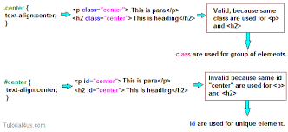

**8) What are the various formatting tags in HTML?**

**ANS)** HTML tags are the keywords that are used to produce web pages in various formats. Opening tags and closing tags are found in the majority of tags.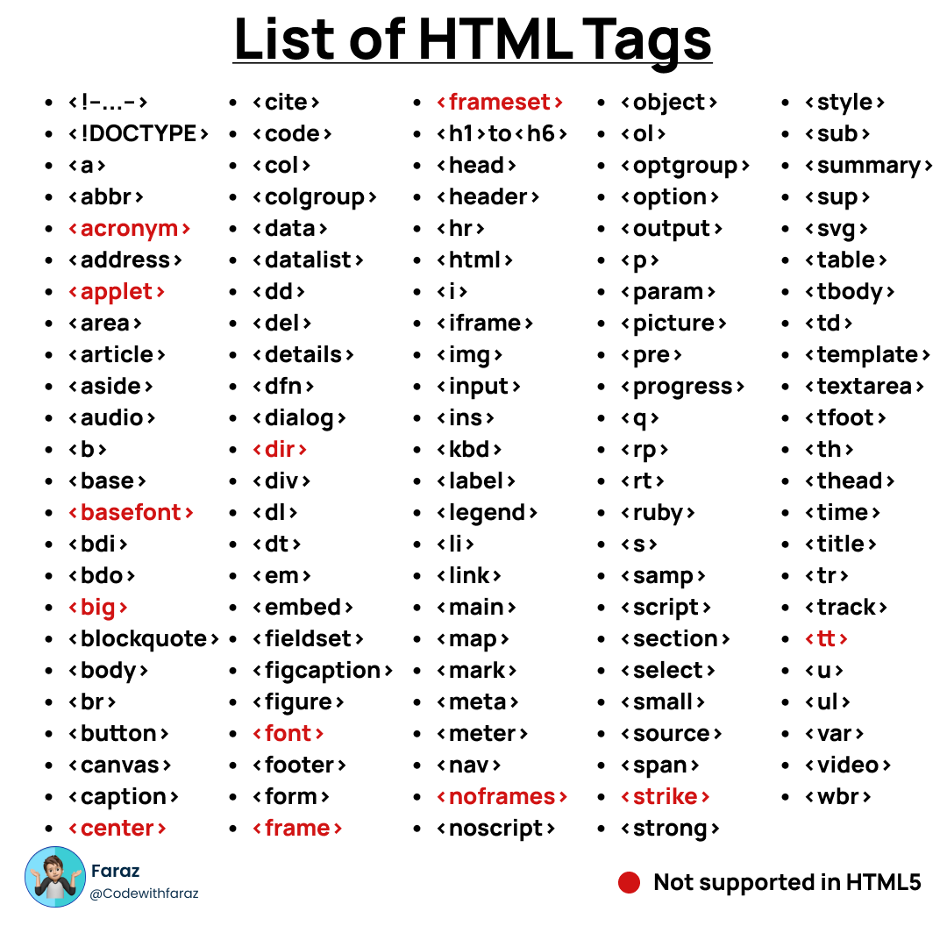

**9)** **How is Cell Padding different from Cell Spacing? With Example.**

**Cellpadding:**

Cell padding defines the space between the content and border of the cell.

**<table cellpadding="value" >.....</table>**

**Cellspacing:**

**cellspacing Attribute** is used to specify the space between the cells.

**<table cellspacing="value" >.....</table>**

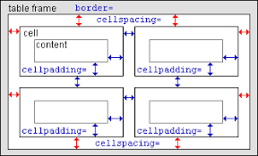

**10)** **How can we club two or more rows or columns into a single row or column in an HTML table? With Example.**

**ANS)** WITH THE HELP OF ROWSPAN WE COULD CLUB THE COLUMNS AND WITH THE HELP OF COLSPAN WE COULD CLUB THE ROW.

ROWSPAN:- The rowspan attribute in HTML specifies the number of rows a cell should span.

COLSPAN:- The colspan attribute in HTML specifies the number of columns a cell should span

EXAMPLE: 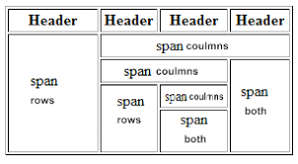

**11)** **What is the difference between a block-level element and an inlineElement?**

**ANS)**

**BLOCK ELEMENT:-**

Block elements always start from a new line. Block elements cover space from left to right as far as it can go.

**INLINE ELEMENT:-**

Inline elements never start from a new line. Inline elements only cover the space as bounded by the tags in the HTML element.

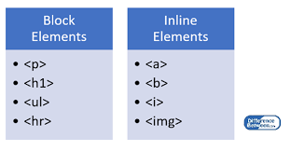

**12) How to create a Hyperlink in HTML? With Example.**

**ANS)** A hyperlink, also called a link or web link, contains an address for a destination and acts as a reference to data

 "Computer Hope home page" is a hyperlink to the Computer Hope home page.

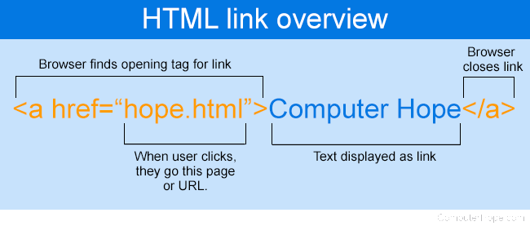

<a href= “hope.html”>computer hope<a>

In this computer hope is a link and “hope.html” is a main folder which was open by clicking on the link

**13)** **• What is the use of an iframe tag? With Example.**

**ANS)** The iframe in HTML stands for Inline Frame. The ” iframe ” tag defines a rectangular region within the document in which the browser can display a separate document, including scrollbars and borders.

<iframe src="https://www.w3schools.com" title="W3Schools Free Online Web Tutorials"></iframe>

The most common use of an iframe is to load content from another site within the page

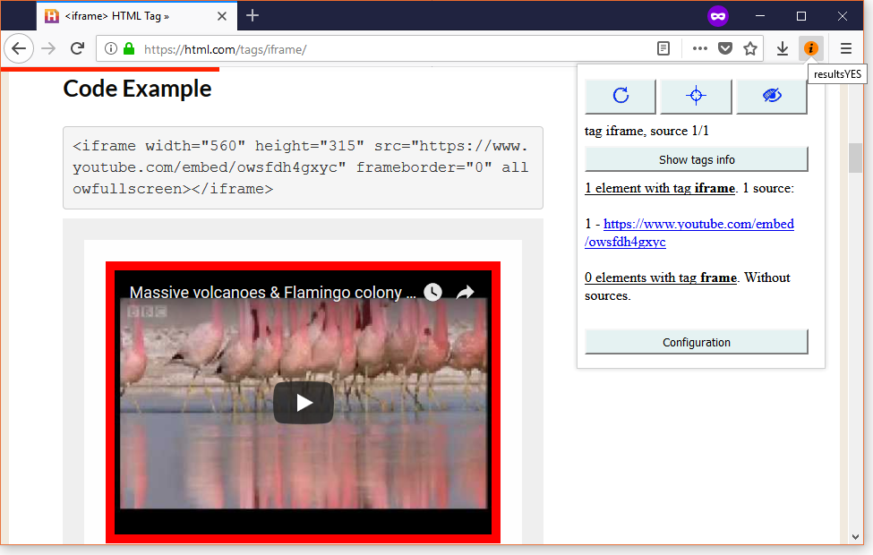

**14) What is the use of a span tag? Explain with example?**

**ANS)** The <span> tag is an inline container used to mark up a part of a text, or a part of a document.

The <span> tag is much like the <div> element, but <div> is a block-level element and <span> is an inline element.

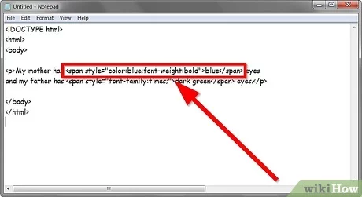

<P>I AM A STUDENT OF <SPAN>WEBSITE </SPAN> DESIGNING</P>

**15) How to insert a picture into a background image of a web page?With Example**.

**ANS)** using the background image attribute inside the <body> tag.

1.Copy the URL of the image you wish to insert.

2.Next, open your index.html file and insert it into the img code. Example: <img src=”(your image URL here)”>

3.Save the HTML file. The next time you open it, you'll see the webpage with your newly added image.

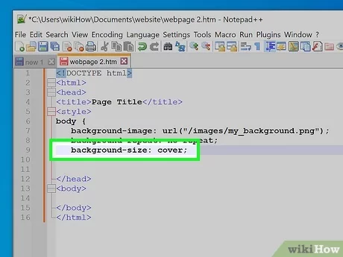

WITH THE HELP OF THIS METHOD WE INSERT A BACKGROUND IMAGE IN WEB PAGE

**16)** **How are active links different from normal links?ANS)**

ACTIVE LINK:

Active Links shows that the browser is in the process to load a new resource. Active links are those links, which have just been clicked at that instant.

NORMAL LINK:

Normal links are links which are there on the page and have not been clicked yet. A normal link is just a line of code that contains a pointer to another resource. An active link is that line of code in action, opening that other resource,

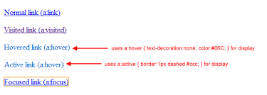

17) **What are the different tags to separate sections of text?**

**ANS)**

THESE ALL TAGS ARE USING FOR SEPARATE A SECTION

1. <br> tag – It is used to separate the line of text. It breaks the current line and shifts the flow of the text to a new line.
2. <p> tag–This tag is used to write a paragraph of text.

3) <blockquote> tag–This tag is used to define large quoted sections.

18) **What is SVG?**

**ANS)**

SVG is used to define vector-based graphics for the Web.

Every element and every attribute in SVG files can be animated.

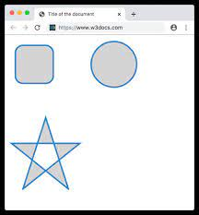

SVG has some predefined shape elements that can be used by developers: Rectangle <rect> Circle <circle> Ellipse <ellipse> Line <line>

SVG has several methods for drawing paths, boxes, circles, text, and graphic images.

**19) What is difference between HTML and XHTML?**

**ANS)**

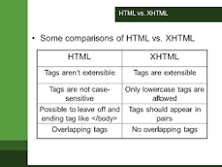

The main difference between them is the syntax and structure;

HTML is more lenient in its syntax, while XHTML has a more strict syntax and follows XML rules.

XHTML is considered the successor to HTML, and its strict syntax makes it more suitable for future technologies and advancements.

HTML is SGML based, whereas XHTML is an XML-based language.

**20) What are logical and physical tags in HTML?**

**ANS)**

Logical tags are used to tell the browser what kind of text is written inside the tags. They are different from physical tags because physical tags are used to decide the appearance of the text and do not provide any information about the text.

: Physical tag: These tags are used to provide the visual appearance to the text.

Logical tag: These tags are used to add some logical or semantic value to the text.

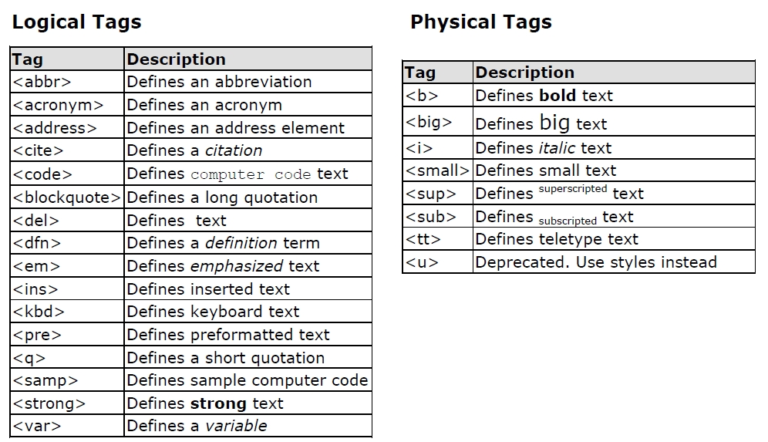

***THANK YOU***